EXECUTIVE BOARD

MEMBERSHIP APPLICATION

Name: ________________________

Department: ________________________

Mailing Address: ____________________

__________________________________

Email: ____________________________

Telephone: ________________________

* Active Membership $25
* Affiliate Membership $25

**Please mail completed application to:**

NDFSIS

c/o Lydia Citta

1012 N 8th Street

Bismarck, ND 58501

|  |  |
| --- | --- |
| **President** – Nathan Bennett  Devils Lake Fire Department  **Vice President** – Jason Wolsky  Carrington Fire Department  **Secretary/Treasurer** – Lydia Citta  Bismarck Rural Fire Department | NORTH DAKOTA  FIRE SERVICE  INSTRUCTOR  SOCIETY |

**North West Region** – Ryan Miller

Williston Fire Department

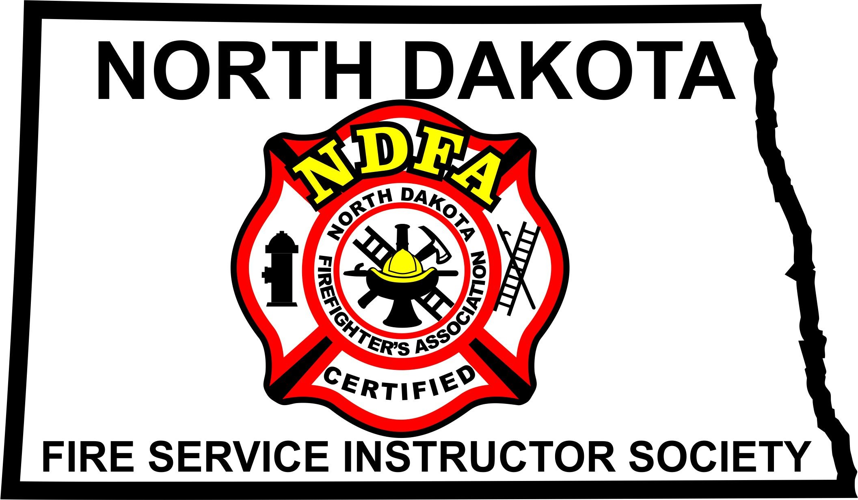**North East Region** – Lee Gessner

Devils Lake Fire Department

**South East Region** – Kellen Jorgensen

West Fargo Fire Department

**South West Region** – Jared Hopkins

Mandan Rural Fire Department

**NDFA Representative** - Rob Knuth

NDFA Training Director

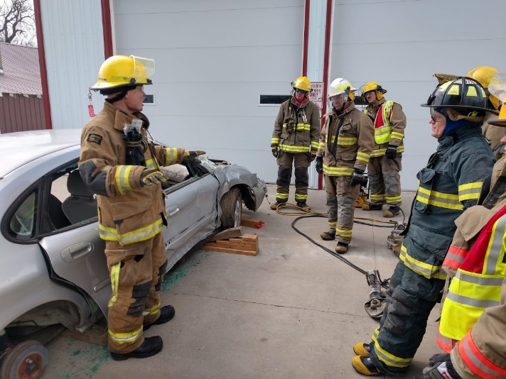**NDFA Representative** – Chris Demello Rice

NDFA Training Coordinator

**OUR OBJECTIVES**

The major objectives of the Society shall be:

1. To promote and assist in the training and education of the North Dakota Fire & Rescue Service.
2. To assist in the development of Fire & Rescue Instructors.
3. Provide and encourage attendance in classes & programs, which will lead to the continuous professional development of North Dakota Fire Service Instructors.
4. Provide designated representatives to professional groups, such as the Certification Advisory Committee, for promoting training and education programs of the Society, while also providing an avenue to receive information on future needs or directions of the Society.

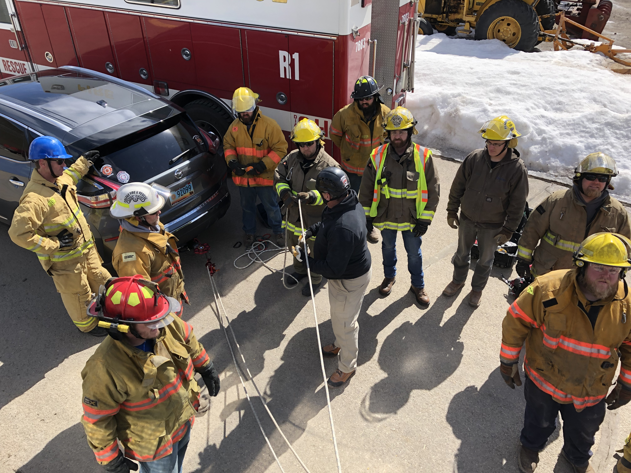

**WHO IS ELIGIBLE FOR MEMBERSHIP?**

**“Active Membership”,** shall consist of individuals who reside in or, are associated with a fire and/or rescue agency within the State of North Dakota; and who meet the minimum standards to instruct, as defined by the North Dakota Firefighter's Association.

**“Affiliate Membership”,** shall consist of individuals who do not meet the criteria for “Active Membership” but pay dues. They cannot vote or hold office.



**WHAT IS NDFSIS?**

As North Dakota Fire Service Instructors, we are charged with the task of training fire and rescue personnel throughout the state of North Dakota. The North Dakota Fire Service Instructor Society (NDFSIS) has been created to establish a channel of communication between instructors, provide a means of improving the quality of our instructors and a means of sharing information and resources.

**WHO IS BEHIND IT?**

NDFSIS was founded by ND Fire and Rescue instructors, who provide mentorship and resource support to improve the quality of the instructors in the state.

The governing body of NDFSIS is composed of an Executive Committee consisting of a President, Vice President, and Secretary/Treasurer and the Regional Board members consisting of one representative from each of the four regions in the state as defined by the North Dakota Firefighters Association.